January 2023

Embedding Work-Based Learning
Directions:
- List each course in the identified program.
- Identify the Work-Based Learning (WBL) experiences each course provides. WBL experiences listed on page two and in the Iowa Work-Based Learning Guide.
- For each of the WBL experience in the course, select and an ICAP reflection to be used or developed. More information about ICAP reflections on page two.
WBL Program _____________________________________________________________________________________________________
Course | WBL Experience(s) | ICAP Reflection(s)s

WBL Experiences | Individual Career and Academic Plan (ICAP)
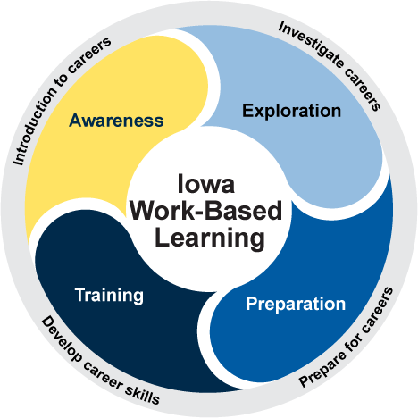  The following are abbreviated definitions of WBL experiences. Full definitions are available in the Iowa Work-Based Learning Guide.  Awareness  - Classroom Speakers: professionals share career information to students  - Informational Interviews: career interview  - Career Immersion Experiences: hands-on simulators/experiences  Exploration  - Authentic Projects: projects completed for industry  - Career-Based Service Learning: community projects with industry & connect it to a career  - Interactive Career Events: career fairs with hands-on career booths  - Worksite Exploratory Events: worksite tour with small group options for informational interviews  - Job Shadows: one or two students at a worksite to observe a professional  Preparation  - Professional Skill Workshops: resume and cover letter writing led by an industry professional  - Mock Interviews: practice interviews with industry professionals  - School-Based Enterprises: student-run business  Training  - Internships: professional training experience for a set period of time  - Quality Pre-Apprenticeships: training experience tied to a registered apprenticeship  - Registered Apprenticeships: on-the-job training to learn a career/trade | What is an ICAP?  ICAP is an individualized career and academic plan that has typically been referred to as a four-year plan created in eighth grade.  What role can an educator play in an ICAP?  Adding a simple reflective activity to work-based learning experiences can help students make informed career decisions.  ICAP Reflection Examples:  - Create an exit slip for students to complete at the end of a class where the prompt is simple for the student and elicits a thoughtful response.  - Create a reflection activity that requires students to use the WBL experience to research more about the career, related career or engage in virtual WBL experiences.  - Create an activity that bridges the experience to additional career learning such as a classroom project or an additional WBL experience.  Educators are encouraged to create their own reflective activities or review more examples on the Department’s Career and Academic Planning website.

